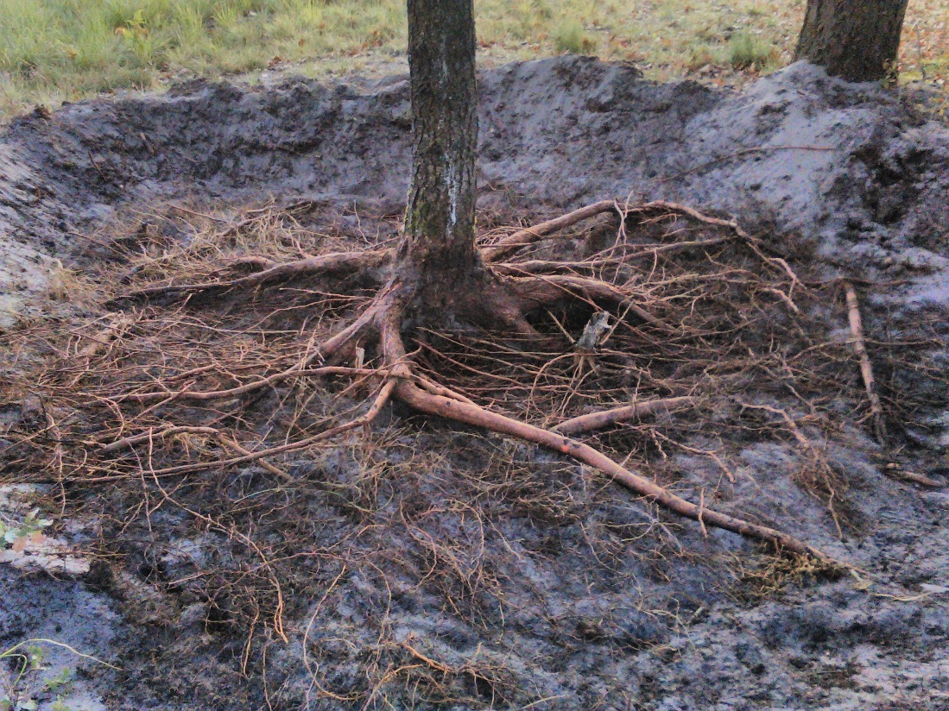

**Figure S1**. Root system of *P. menziesii*exposed after blowing away the upper soil layer. This method was applied in order to a collect high number of root samples with minimal physical damage to the roots.