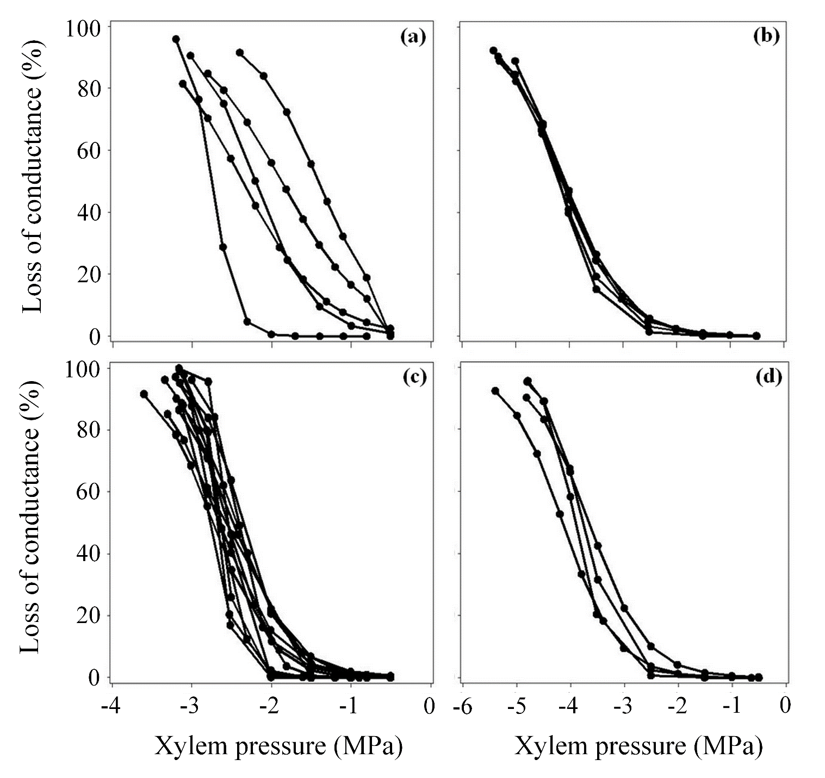

**Figure S2**. Root vulnerability curves (raw data) carried out with the low pressure gradient method **(a, b)** and the no pressure gradient method **(c, d)** showing the percentage loss of hydraulic conductivity in xylem as a function of xylem pressure (MPa) in two Pinaceae species: *Pinus pinaster***(a, c)** and *Pseudotsuga menziesii***(b, d)**.