Instructions for formatting your paper for the Journal of Plant Hydraulics Enter your title here (Times 22)

First A. Author¹, Second B. Author², Third C. Author³ (Times 14)
¹affiliation for first Author; ²affiliation for second Author; ³affiliation for third Author (Times 12).

Corresponding author: First Last, first.last@first.last (Times 11)
Date of submission: date
Date of publication: date

Abstract
Text of your abstract here in Times 11 bold.

Introduction
Text of the introduction in Times 11.

We have developed a dedicated plugin to simplify the very time consuming task of converting your text file to a web document. So please follow strictly our instructions, this is very critical for a painless conversion.

References
References cited in the text should strictly follow this example (AuthorA, 2011; AuthorA and AuthorB, 2012; AuthorA et al., 2013; AuthorD, 2014a; AuthorD, 2014b), and when cited in the text must be given as AuthorA (2011) or AuthorA et al. (2013) in the text. Note the position of the punctuation (, and ;)!

Headings and styles
It is critical that you keep the same styles as defined in this document:
- The title of the article should have Titre/Title as style
- The titles Abstract/ Materials and Methods/ Results/ Discussion/ Acknowledgments/ References should have Titre 1 or Heading 1 as style
- Figures and Tables titles should have Titre 5 or Heading 5 as style
- Figures and Tables legends should have Titre 6/7 or Heading 6/7 as style
- Everything else should have Normal as style.

Police and format
You can only one police is used so far. You may format your text using these styles: normal ^{exponent} _{indices} italic bold underline crossed and any combination of those styles like this.
Use the Insert-Symbol function to insert greek (αβφξΛ) or specific symbols (✔©€). Do not use the 'symbol' or 'windings' polices, they will not be converted properly.
Your may include hyperlinks in your document.

Figures
Figures should be included in the text only as JPG, PNG, or TIFF images. You should include a title to your figure (Heading 5 style) and a legend (Heading 7 style)

Equations
Use your 'equation' plugin to insert equations in your file:

$$PLC=\frac{100}{1+exp(a(P-b))}$$

Materials and Methods
Text of the Materials and Methods in Times 11.

Results
Text of the Results in Times 11.

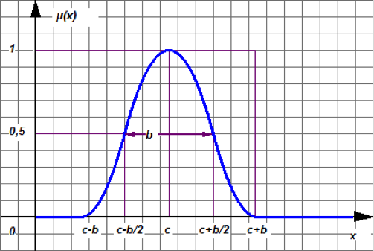

Figure 1: Title the figure here in Times 10 bold.

Text of the legend in Times 10.

Table 1: Title of table 1 Times 10 bold. Insert this title before the table
Title 1 | Title 2 | Title 3 | Title 4
data 1a | data 2a | data 3a | data 4a
data 1b | data 2b | data 3b | data 4b

Legend of table 1 Times 10. Insert this legend after the table.

Discussion
Text of the discussion in Times 11.

Acknowledgements
Enter the text of the acknowledgements in Times 11.

References
AuthorA A.B., 2011. Title of the paper. Journal of Plant Hydraulics 1: e-001.
AuthorA A.B., AuthorB C., 2012. Title of the paper. Plant Physiology 162: 181-187.
AuthorA A.B., AuthorB C., AuthorC B.C., 2013. Title of the paper. Tree Physiology 16: 18-25.
AuthorD F.B., 2014a. Title of the paper. Journal of Plant Hydraulics 3: e-007.
AuthorD F.B., 2014b. Title of the paper. The Sigmoidal Journal 1: e-001.
AuthorA A.B., AuthorC B.C., 2013. Title of the paper. Plant Physiology. doi:10.1111/j.1755-0238.2008.00004.x.

The number of references is limited to 50.

