Instructions for formatting your paper for the *Journal of Plant Hydraulics* Enter your title here (Times 22)

First A. Author1, Second B. Author2, Third C. Author3 (Times 14)

1affiliation for first Author; 2affiliation for second Author; 3affiliation for third Author (Times 12).

**Corresponding author**: First Last, first.last@first.last (Times 11)

**Date of submission:** date

**Date of publication:** date

# Abstract

**Text of your abstract here in Times 11 bold.**

# Introduction

Text of the introduction in Times 11.

We have developed a dedicated plugin to simplify the very time consuming task of converting your text file to a web document. So please follow strictly our instructions, this is very critical for a painless conversion.

*References*

References cited in the text should strictly follow this example (AuthorA, 2011; AuthorA and AuthorB, 2012; AuthorA *et al.*, 2013; AuthorD, 2014a; AuthorD, 2014b), and when cited in the text must be given as AuthorA (2011) or AuthorA *et al.* (2013) in the text. **Note the position of the punctuation (, and ;), and *et al* in italics!**

***VERY IMPORTANT: Headings and styles***

It is critical that you keep the same *styles* as defined in this document. If you copy and paste your manuscript onto this template document, the style will not be copied. You will need to manually set this prior to submitting your manuscript. It really isn’t that difficult. Simply select the text you would like the style to be modified to, and click on the appropriate *style* (under Home-> styles) as listed below:

- The title of the article should have Title as *style* (Titre in French)

- The titles Abstract/ Materials and Methods/ Results/ Discussion/ Acknowledgments/ References should have Heading 1 as *style* (Titre 1 in French)

- Figures and Tables titles should have Heading 5 as *style* (Titre 5 in French)

- Figures and Tables legends should have Heading 7 or as *style* (Titre 7 in French)

- Everything else should have Normal as *style*.

*Police and format*

You may format your text using these styles: normal exponent indices *italic* **bold** underline ~~crossed~~ and any combination of those styles.

Use the Insert-Symbol function to insert greek (αβφξΛ) or specific symbols (✔©€). Do not use the 'symbol' or 'windings' polices, they will not be converted properly.

You may include [hyperlinks](http://jplanthydro.org) in your document.

*Figures*

Figures should be included in the text only as JPG, or PNG images. You should include a title to your figure (Heading 5 style) and a legend (Heading 7 style)

*Equations*

Use your 'equation' plugin to insert equations in your file:

$$PLC=\frac{100}{1+exp(a(P-b))}$$

# Materials and Methods

Text of the Materials and Methods in Times 11.

# Results

Text of the Results in Times 11.

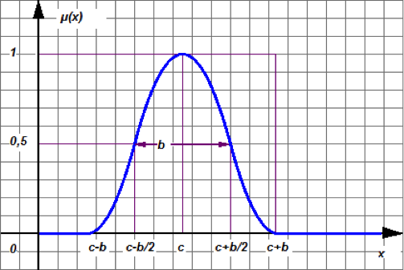

##### Figure 1: Title the figure here in Times 10 bold.

Text of the legend in Times 10.

##### Table 1: Title of table 1 Times 10 bold. Insert this title before the table

|  |  |  |  |
| --- | --- | --- | --- |
| **Title 1** | **Title 2** | **Title 3** | **Title 4** |
| data 1a | data 2a | data 3a | data 4a |
| data 1b | data 2b | data 3b | data 4b |

Legend of table 1 Times 10. Insert this legend after the table.

# Discussion

Text of the discussion in Times 11**.**

# Acknowledgements

Enter the text of the acknowledgements in Times 11**.**

# References

Authors are responsible for crosschecking their citations against their bibliographie and must respect the style requested by OENO One.

* APA Style is mandatory (APA 7thedition)

- In the body of the text, bibliographic references should be listed like this:

- (Name1 *et al*., 2019; Name2 *et al*., 2019)

- (Name1 and Name2, 2017a; Name1 and Name2, 2017b)

- If 2 authors only: (Name1 and Name2, 2019) – do not use &

- According to Name *et al*. (2019)

In References, bibliographic references should be listed alphabetically and APA style is mandatory (with doi when available).

They should be formatted like this:

o Name, A. A, Name, B. B, & Name, C. C. (2010). Title of the document. Journal, 21(1), 57 75. https://doi.org/xxxxxxxxxxx

o Name, F. (2013a). Title of the document. Journal , 31(3), 466–467. https://doi.org/xxxxxxxxxxx

o Name, F. (2013b). Title of the document. Journal, 16, 491-498. https://doi.org/xxxxxxxxxxx

• If doi are missing or if you need help with APA style:

o **Doi are available here: https://apps.crossref.org/SimpleTextQuery/ (You just have to copy/past the bibliographic references)**

o You can use Zotero or Mendelay or the APA style generator: https://www.scribbr.com/apa-citation-generator/#/